1 The hexagon ABCDEF is in a circle where AF=31, and the other sides have the lenght of 81. Calculate the sum of the lenghts in the hexagons diagonals that starts from A.

2. Let a,b,c be lenghts of the sides in a triangle, show that:
(a+b-c)(a-b+c)(-a+b+c) ≤ abc.
When does equality occur?

3.Ten kids went to pluck mushrooms in the woods. Nobody came home with nothing, and all togheter they had collected 54 mushrooms. Show that at least two of the kids picked the same amount of mushrooms.

4.A box in a corner in a 3x3 grid is painted black, the other boxes are white. In one move, you are allowed to switch color on all boxes in a row or column. Can you after a number of such moves make all boxes black?

5.Little Aaron har removed seven pages of a notebook. Can the sum of the removed pages side numbers be equal to 300?

6.Inside a 5x5x5 cube, 124 points are chosen. Show that inside this cube, you can place a 1x1x1 cube that won’t contain any of the chosen points (none of the points are inside the smaller cube. It can be placed anywhere, even on the slope).

7.Peter’s square patio is covered with concrete-plates. Some of the plates have the shape of 2*2 bricks, and some have shape of 1*4 bricks. One of the plates is broken, but as a replacement Peter only have a single plate of the other kind. Can he replace the broken plate with a the one he has by possibly rearranging the plates on the patio?

8.Show that the number A=(5^99)+(11^99)+(17^99) can be divided with 33

9.Show that 7 is a divider to 2222^5555 + 5555^2222

10.Which rest do you get when 9^2014 divides with 11?
11.When Anna splits the candy pieces from her big easter egg in piles of 4 pieces, she gets 3 left over. When she splits it in piles of 5 pieces, she gets 4 left over. When she splits it in piles of 6 pieces, she gets 5 left over. How many pieces are there in the easter egg if we know that its less than 100?

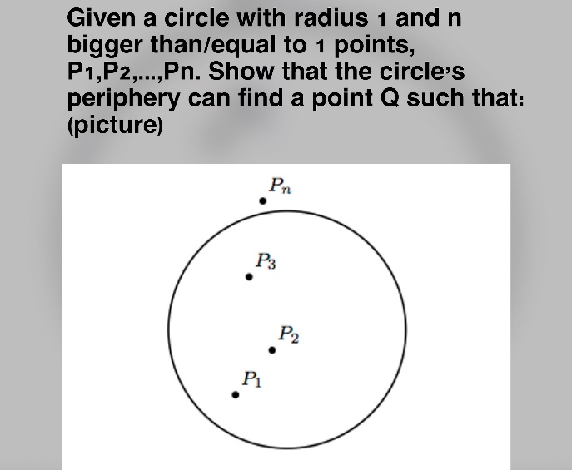
12.

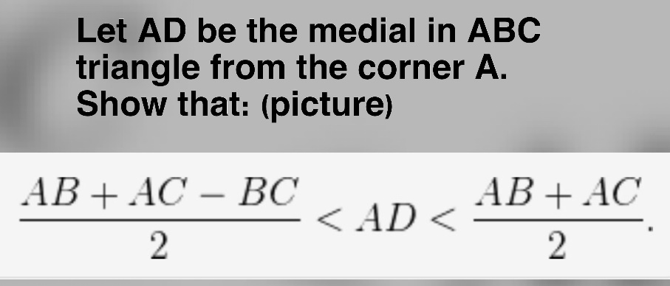
13.

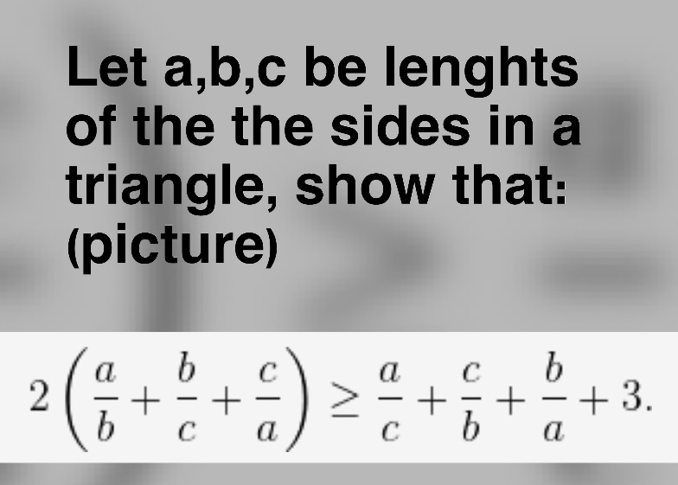
14.

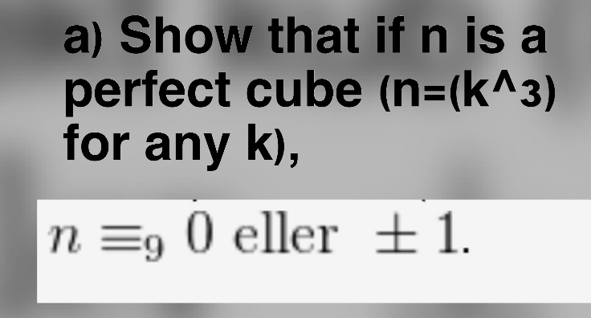
15. a)

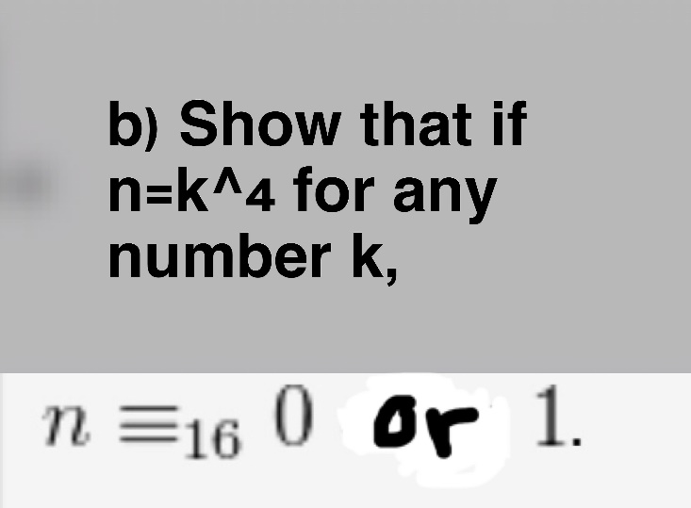
b)

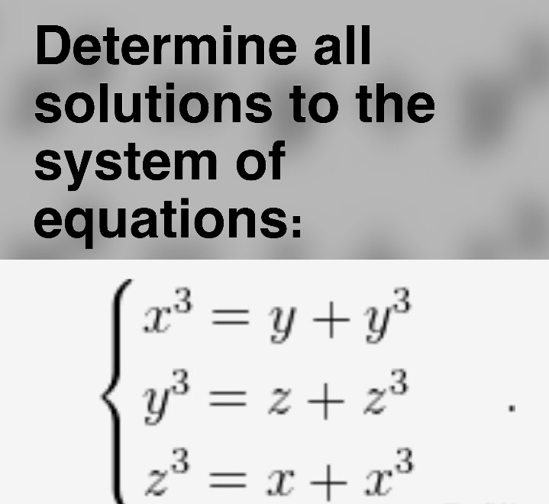
16.

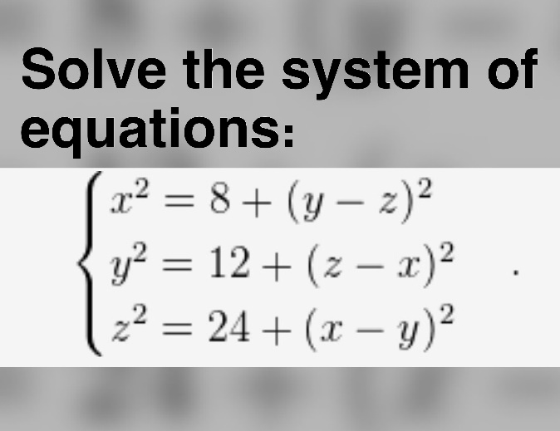
17.

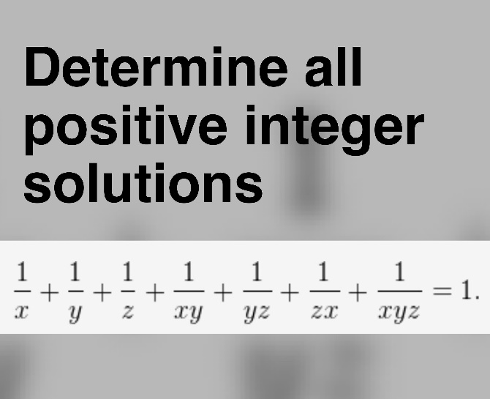
18.

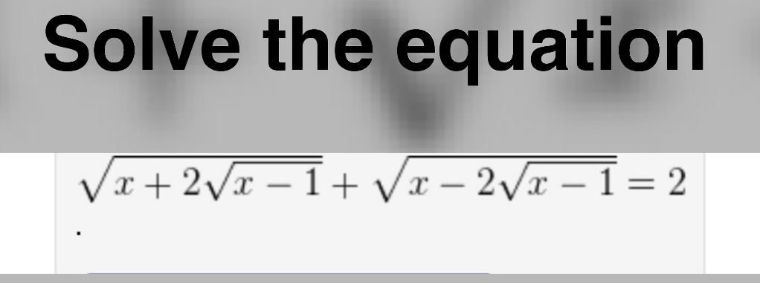
19.

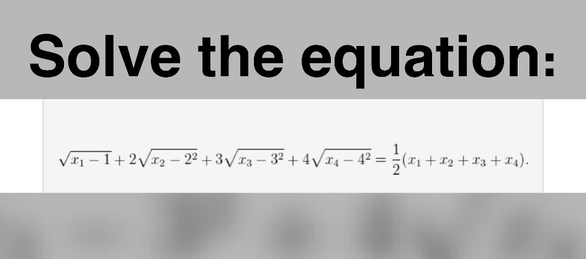
20.

